**Screenshots from steps 3 and 5**

**Step 3:** Google Earth downloaded on laptop and .kml file comprising of the 13 locations captured below. (Please find the locations with blue points in the map below)

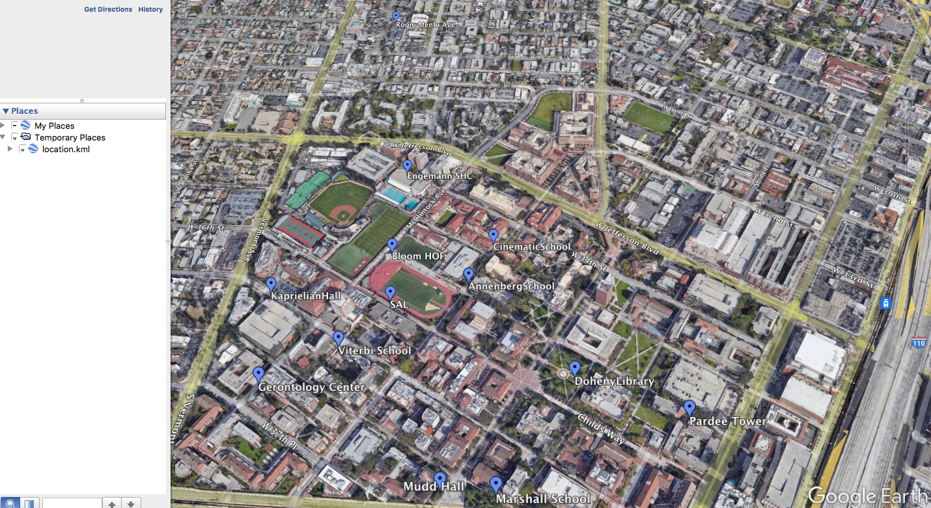

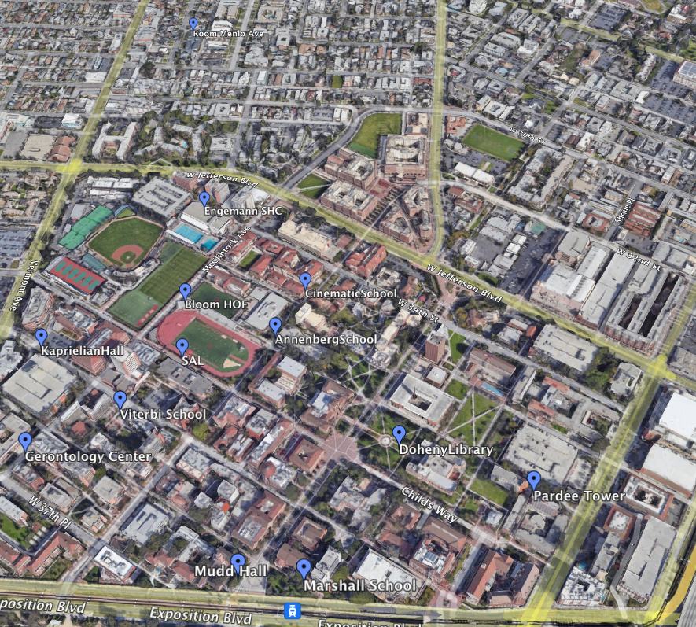

**Step 5:**

1. **Convex Hull (only)**

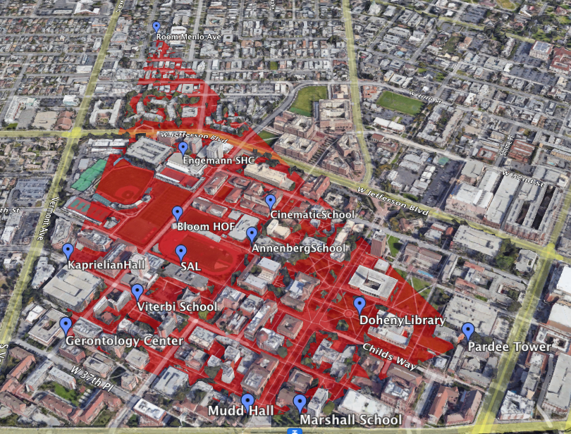

1. **K-Nearest Neighbors**

